BS-401/BS-801
Color Sensor User Manual

Part Descrition:

BS-401/BS-401P no channel digit display, no channel optional

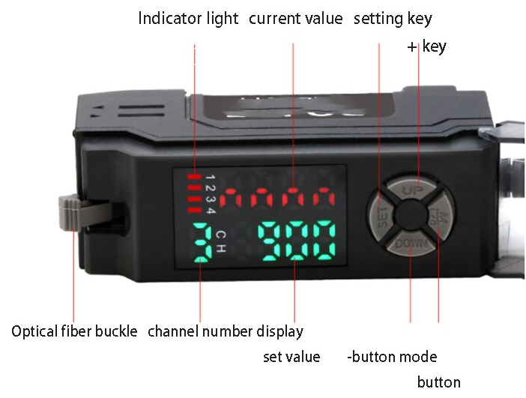

Attention:

To ensure safety,please follow the below regulations when using sensor:

1、This product only use for detecting object. Never use it as a sensing device for personnel protection.
2、This product can’t be used as an explosion-proof product.Please don’t use this product in hazardous place or the place with potentially explosive gases.
3、This product input DC power, Prohibit use AC power.Otherwise, it will cause product explosion and be on fire
4、Please don’t wire the amplifier along with the power or high-voltage lines,otherwise the sensor be damaged.
5、When using commercial switch voltage regulator,please ensure frame ground terminal and ground terminal ground connection.
6、Please don’t use this item outdoor or in the location where external light can enter the receiving surface.

Specification:

Model | BS-401/BS-801 | BS-401P/BS-801P
 | NPN | PNP
Type | BS-401/401P single output port， BS-801/801P 4 output port cable-type
Control Output | BS-401/401P single output port， BS-801/801P 4 output port
Light Source | RGB LED
Response Time | C mode 130uS
Output Operation | LIGHT-ON/DARK-ON（switchable either）
Indicators | Operation indicator：RGB LED、dual digital monitor：7 digit display，threshold value（4 green digit ）and present value（4 red digit) lights up at same time. Present value range: 0-999
Detection Mode | Color auto-match detection C，different colors automatically select different light sources for detection
Timer Function | OFF-delay /ON-delay /One-shot/ ON one-shot delay optional. timer range(ms)： 1ms ~ 9999ms
Output Control | NPN/PNP open-collector transistor 24V，Maximum 100mA(only console）Maximum 20mA (when connection component, residual voltage :1V.
Supply Power | 12 ~ 24V DC±10%，ripple（P-P): 10% or less class 2
Ambient Illuminance | Incandescent light: 20,000lux or less, sunlight: 30,000lux or less
Power Consumption | Normal Mode：300mW or less Voltage: 24V or less | Normal Mode: 300mW or less Voltage: 24V or less
Vibration Resistance | 10 ~ 55Hz，Dual amplitude:1.5mm，in X,Y and Z directions each 2 hours
Ambient Temperature | -10 ~ +55℃ , no freezing

Circuit and Wiring Diagram:
BS-801 NPN model【BS-401 no 2、3、4 output】
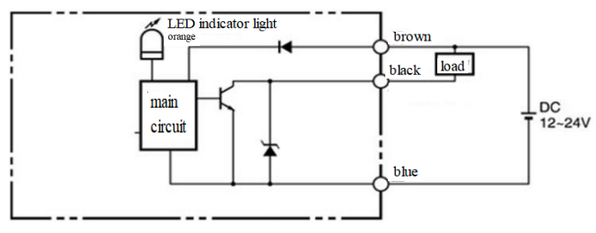
Connect DC 12-24V power supply
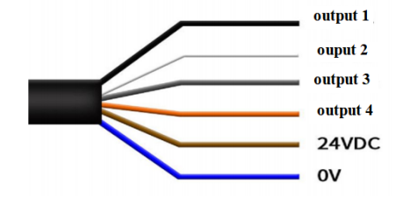

Mounting:
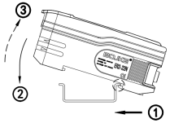
Using a DIN rails
- Mount:Align the bottom slot with the track.
push the console to direction ① meanwhile
tilt it in direction ②.
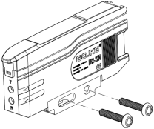
- Remove:push the console
to direction ① meanwhile lift it in direction ③.

Install on wall (only suitable for console )
Install the console along with frame, and then use 2
piece M3 screw fix them.

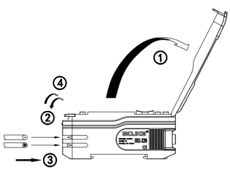
Connection optical fiber component
1, Open the dust cover in the direction ①.
2, Move down the optic fiber locking rod to the direction ②.
3, Insert the optic fiber component marked length into hole of optical fiber.
4,Move down optic fiber locking rod to direction ④ .
5,If the fiber component thinner, must use adapter which provide together
6, If don’t connect the suitable adapter, the thinner fiber component can not detection product well (adapter along with the optic fiber component)
7,If connect Amplifier with coaxial reflective type,should connection transmit with single core fiber, connect multi core fiber with receiver.

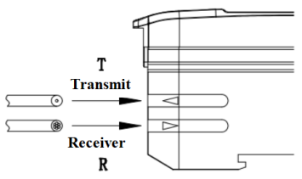
Setting:
Short press MODE to cycle switching channels 1.2.3.4.5 (where 5 is the received light value of the current channel). The setting method for each channel is the same
Two point calibration in default mode:
Step1, when no object, press SET key within 2 seconds.
Step 2, put a object front of fiber, press SET key within 2 seconds.
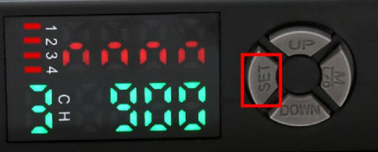
The values measured in two steps and the RGB detection channel will be displayed on the screen and automatically memorized and stored
C mode selection 1P calibration self-learning: Align the optical fiber with the color to be detected, press SET once, and the sensor will automatically record the current color matching value and brightness value as the judgment standard for normal operation.
Sensitivity setting:
Press UP/DOWN key can adjust value (see below:)

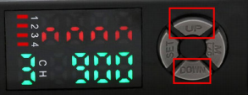
1, after press UP/DOWN key, you can adjust when digit value blink.

2, hold on the key, the speed will increase
Operation Function:
When display red and green digit value, short press UP or Down keys can adjust green digit value. In default status, red digit value 50 more than green digit value can stable detection.

Manual:
Short press M key, to cycle switching channels 1.2.3.4.5 (where 5 is the received light value of the current channel).
Each channel can set the memory color according to press SET key, the corresponding indicator will light up, and the output line will output.
Press and hold on M key 3 seconds enter into follow process:
First manual

E-2P 0

E-1P 0
2P mode for 2-point calibration，Press SET key once for the color which need detection. Press SET key again against background color to complete the calibration. Suitable for only two contrasting colors.
1P mode is a single calibration,press SET key once for the color which need detection.(suitable for selecting one from multiple colors)
Can be switched through UP or DOWN keys
Short press M key again, Enter into second manual
A-H 0
A-L 0

Can be switched through UP or DOWN keys
When the test object is too close to the product or the product has high reflectivity, and the feedback light is too strong and saturated, A-H can be adjusted to A-L using the UP/DOWN key to exit the saturation state and perform normal detection.

Short press M key again, enter into third manual

C 0
The C mode is a universal color matching detection mode, when digit screen display 1000 means the same color, in fact 900 normally is considered the same color.
Note:can not switchable mode

Press M key again, into forth manual

5. L-on

d-on
- on normally open mode, sensing the set color output, other colors are not output; d-on normally closed mode, sensing the set color not output, other colors output.
Can be switched through UP or DOWN keys

OFFD - - - -

ON-D - - - -

ONOD - - - -
Exit manual

Press M Key again, into fifth manual
Timer function
TOFF 0 TOFF position
press M press UP or DOWN keys enter timer mode

OFFD 10
In timer mode, displayed OFFD, after pressing the MODE key, display number 10, press UP or DOWN key to adjust the value , and the value will be automatically memorized and stored.
ON-D 10

ONOD 10

Timer mode: When OFFD, sensing object present, after object absent, till the delay time then disconnect.ON-D, sensing object present till the delay time then output;ONOD, OFF delay and ON delay at same time.

Short press M key
END

Lock Setting
Using the lock function can stop all keys functions
All keys will be lock when press M and DOWN keys above 3 senconds at same time. Again press M and DOWN keys above
3 second, lock function release.
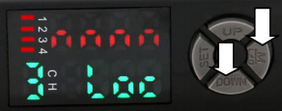

Initialization setting:
Press M and SET keys over 3 seconds at same time when both red and green are digit value. Return to factory setting when display “rSE”.

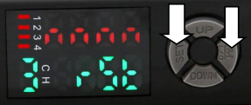

Error Code
nnnn If the light feedback is too low and the product may not be detected, it is necessary to shorten the detection distance, use more thicker core of fiber, or increase the detection surface area. distance, use thicker core fiber, or increase the detection surface area.
uuuu For strong light feedback, can use A-L exit. or increase the detection distance, use thinner core fiber

Product Warranty
When ordering our products only reference sample, the following guarantees, disclaimers, conditions of fitness etc should apply when no special instructions are mentioned in the quotation sheet, contract, specification, etc.

Before order please ensure you read and confirming following.
1、Quality Guarantee Period
Quality guarantee period is one year,calculated from the date when product delivered to buyer’s destination.
2、Range of guarantee
We will repair the commodity free if the damage caused by our company.
It’s will not belong to the range of guarantee if caused by following reason:
- Damage caused by use under conditions except the conditions, environment and use method described in the product manual of the company.
- Faults not caused by our company.
- Product damage caused by the personal modification
and repair except the manufacturer.
- Didn’t according to usage method of our company description
- After the goods are delivered, the problem caused
by unpredictable scientific level
- Other failures caused by natural disasters, disasters and other factors
At the same time, the above guarantee only refers to the company's products, and the other damage caused by the company's product failure is excluded from the guarantee range.
3、limits of liability
1)The Company should not be liable for any special loss, indirect loss, and other related losses (eg:equipment damage, loss of opportunity, loss of profit) caused by incorrect use of company's products.
2)When using programmable equipment, our company will not assume any responsibility for the programming carried out by non-company personnel and the consequences arising therefrom
4、 Suitable for use and conditions
1)The products of our company are designed and manufactured for general products of general industry. So, the products of our company should not be used for the following applications and not suitable for their use.If it is necessary to be used in the following occasions, please discuss with the sales of our company to confirm the product specification, and select the product which suitable. At the same time, we should consider various safety countermeasures, such as the safety circuit that can minimize the danger even if there is a failure.
a.Facilities that have a serious impact on life and property, such as atomic energy control equipment, incineration equipment, railway, aviation and vehicle equipment, medical equipment, entertainment equipment, safety devices and equipment that must comply with the special provisions of administrative agencies and individual industries.
b. Public utilities such as gas, water, power supply systems, 24-hour continuous operation systems and other equipment requiring high reliability.
c. Systems, equipment and devices that may endanger personal and property.
d.Outdoor use under similar or similar conditions.
2)When the user uses the company's products in occasions closely related to personal and property safety, the overall risk of the system should be clear. In order to ensure safety, special redundancy design should be adopted. At the same time, according to the applicable purpose of the company's products in the system, supporting power distribution and settings should be supply.
3)Please be sure to follow the precautions and prohibitions to avoid incorrect use and damage caused by a third party.
5、Range of Services
The product price does not include the dispatch fee of technicians and other service fees. If you have any demand in this, you can contact us to negotiate.

